**Meadowbrook** **Elementary**

**November 2020**

**Dates to Remember:**

November 9th – Marcos Pizza Night

November 9th – Picture Retake Day

November 11th - **No School** – Veterans Day

November 12th – End of 1st Trimester

November 16 th – PTSA meeting

November 22rd – 26th – **Thanksgiving Break** - No School

What’s For Lunch?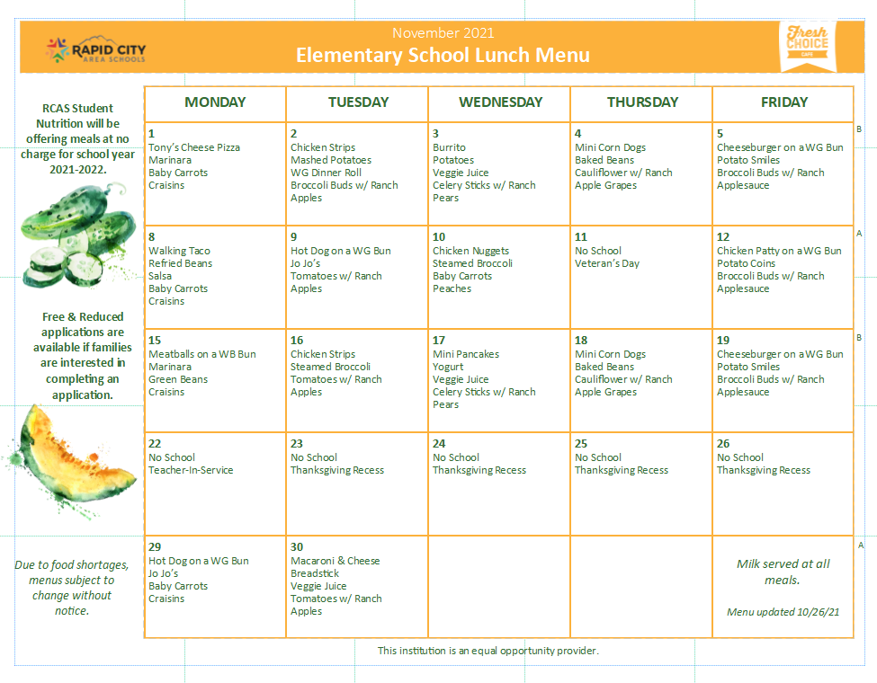

School News!!

**Attendance:**

**If your child is going to be absent due to illness or a personal day, please call the office directly.**

**Late? Student Lunches need to be ordered by 9am,** if your child has an early morning appointment or is running behind, please call Lisa or Kelly in the office so they can ensure a lunch is ordered!

**Tardy?**

Students can come to the Front door, ring the buzzer, and head to the office for a pass to class!

**Early Pick up?**

If you are picking your child up early, please call ahead so we can have the child ready and on the way to the office!

**Celebrations at School**



Please keep in mind when celebrating Birthdays, Holidays and Special Occasions; we have several students with life threatening food allergies and food related health problems. ONLY food commercially prepared and packaged with an ingredient label are permitted. NO food with nuts or peanuts, peanut and tree nut oils are to be brought into the classrooms.

**Pumpkin Carving Winners!!**

Congratulations to Aurora Simonson and Caleb Smith for winning the pumpkin contests this year!  They each won a Elks Theatre Popcorn Booquet and a couple of free Elks movie passes! Congratulations!!

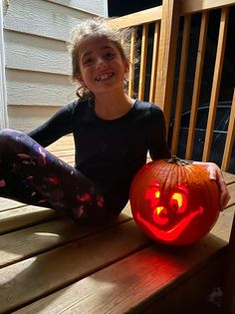 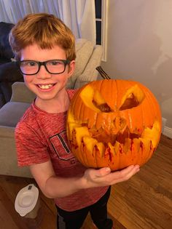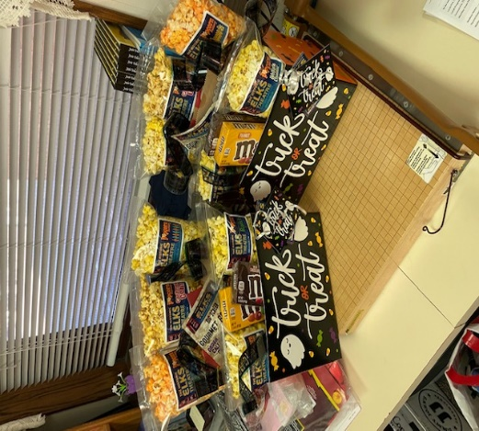 

QDOBA Coupons & Marco’s Pizza??!!

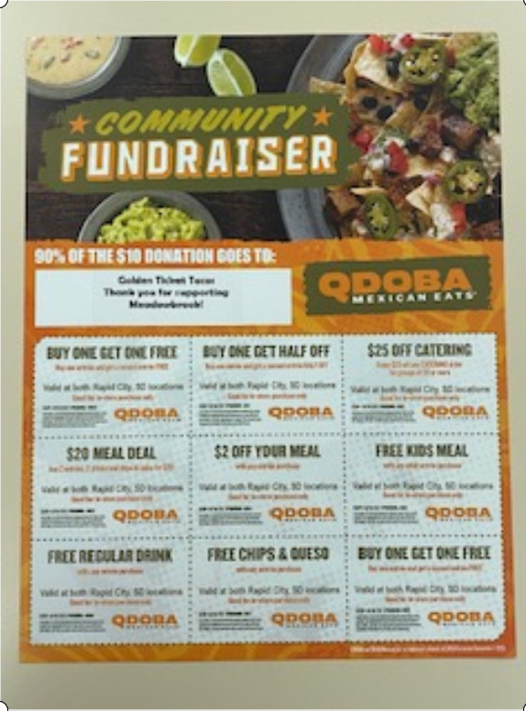Exciting news! We will be selling Qdoba coupons again this year!! The sales will help purchase books and math games for student goal setting. The golden tickets were a huge success last year and we want to do it again. Ask your child what their goal was last year.

**The coupon pages are $10 ea**. Meadowbrook gets 100% of the money raised because a parent generously donated the coupon pages.

The coupon pages are great. There are two buy one get one free coupons and many more. This more than pays for your donation.

Help us out and make an easy meal. No cooking, no dishes, WIN!  
  
All you have to do is send a check (made out to PTSA) or cash to your child’s classroom. Please label it with your child’s name or stop into the office and grab a few from Miss Lisa.

Thank you for all you do to support Meadowbrook!

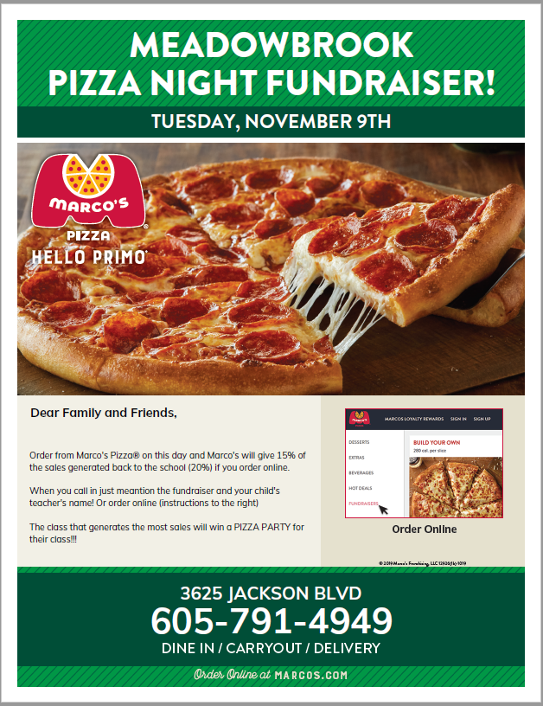

Fund Raisers



Gobble them up!

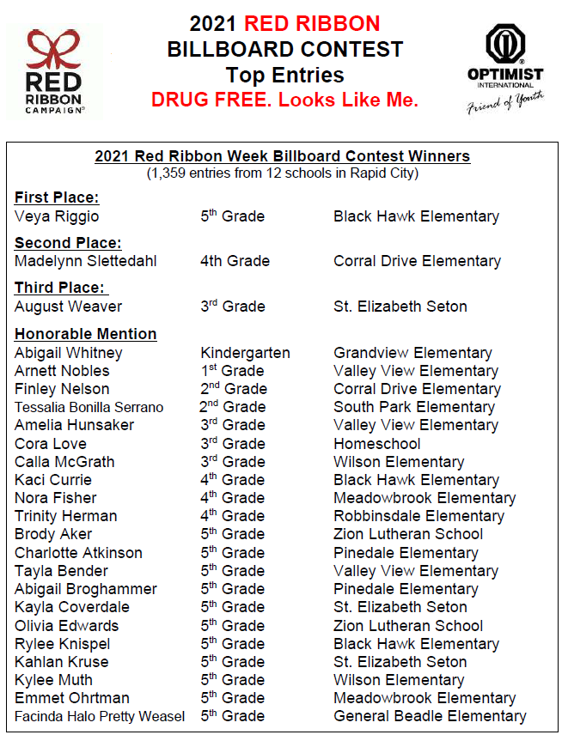  
**Red Ribbon Week Contests**

**Meadowbrook Celebrates Two Students for Honorable Mention: Congratulations Nora Fisher and Emmet Ohrtman!**

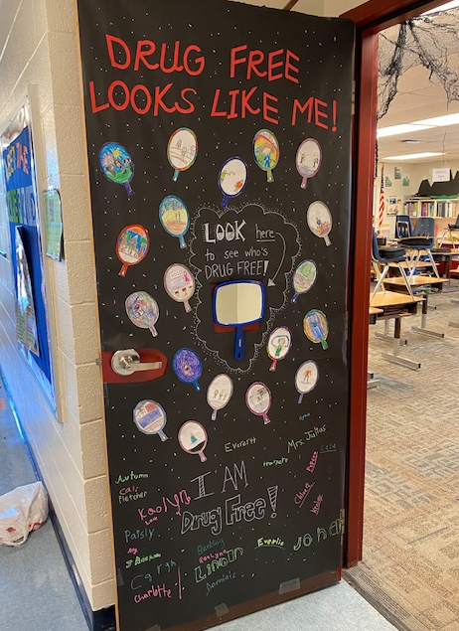

Red Ribbon Door Decorating Contest!! The theme this year was "DRUG FREE, Looks Like Me."  Four Lifeways Counselors served as judges for the contest and the winner: **Ms. Julius 3rd Grade Class!! The all shared in a huge cookie treat From Eileens Cookies! Yummers!** 

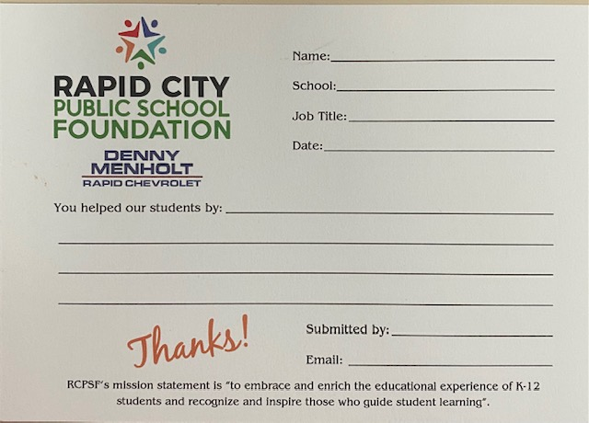Above and Beyond

The Rapid City Public School Foundation wants to recognize those teachers, administrators and staff members who go ***Above and Beyond*** in their dedication to the children and their families in Rapid City Area Schools. Any current employee is eligible to nominate and/or receive the Above and Beyond award. Staff, Students and Parents are encouraged to fill out a nomination card!! This Year’s sponsor is Denny Menholt Rapid Chevrolet! Entries need to be submitted between now and April 15th!! Any questions please check with Lisa or Kelly in the office!



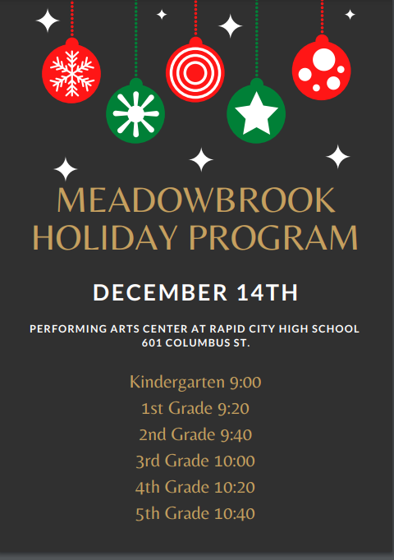

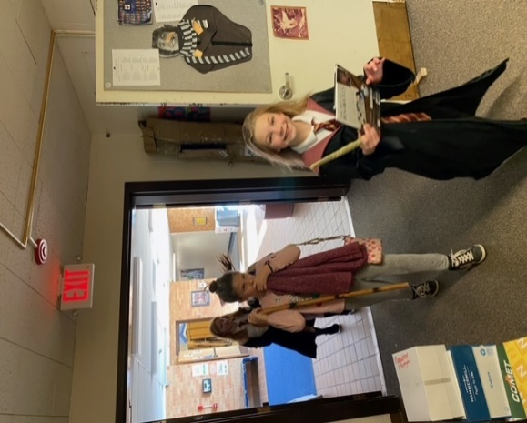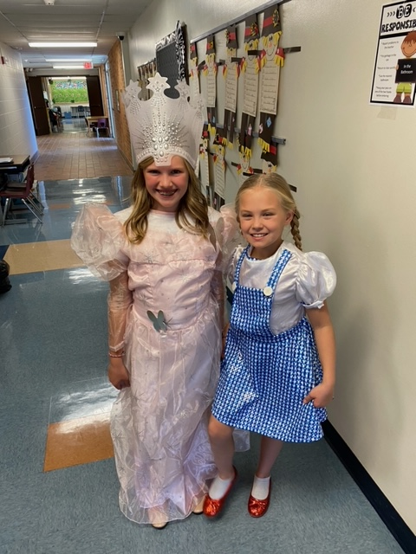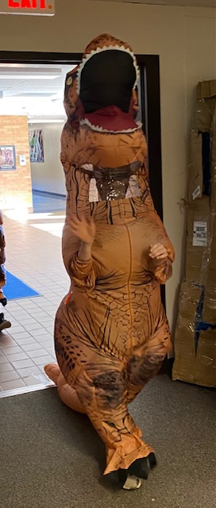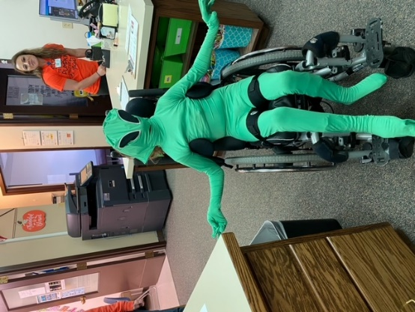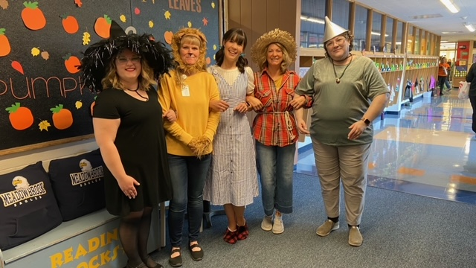

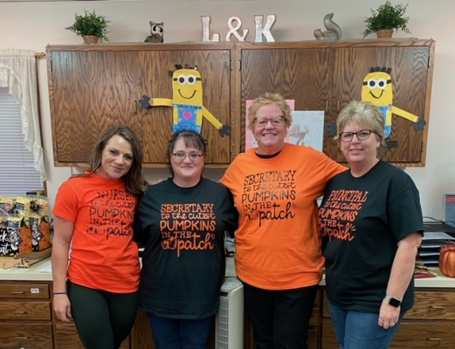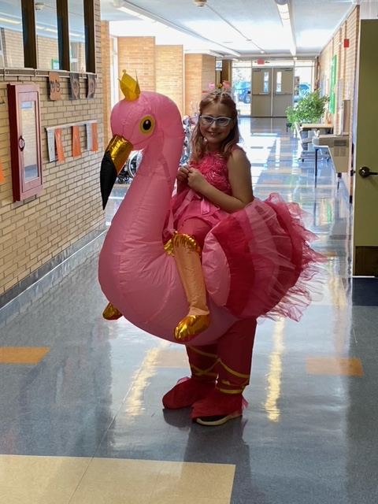

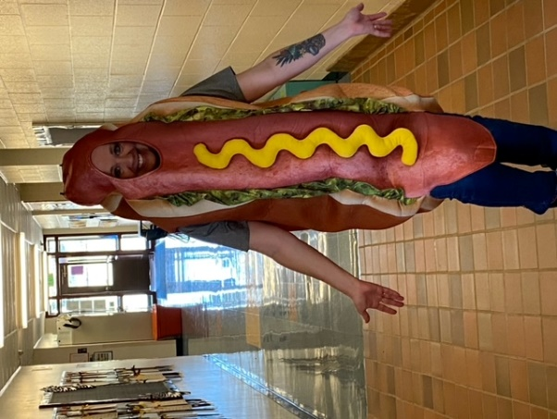

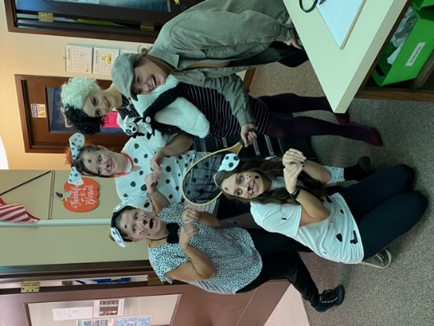

Halloween Madness!!



**Happy Thanksgiving from All of Us at Meadowbrook!**



Cultural Inclusion

Meadowbrook students and teachers had the opportunity to learn more about the Lakota culture. Star Chief Eagle provided lessons and presentations to the classrooms throughout the week! 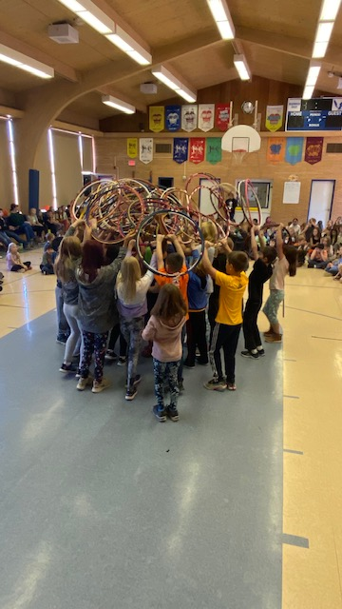 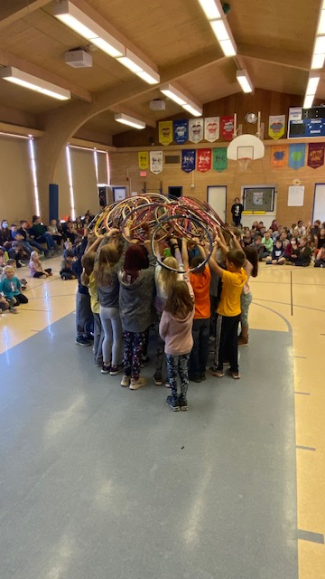 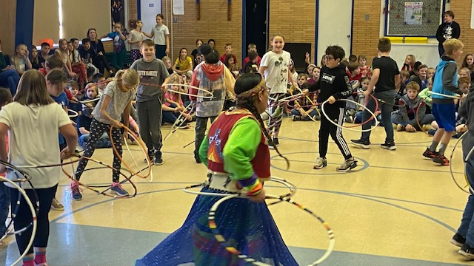

Letter from the PTSA

