 WEST MIDDLE SCHOOL
NEWS CLIPS FOR MARCH 2024

FOR HOMEWORK - PLEASE REFER TO GOOGLE CLASSROOM
DAILY ANNOUNCEMENTS ARE POSTED DAILY ON THE WEST MIDDLE SCHOOL WEBSITE

REGISTRATION FOR 2024-2025
9TH GRADE
Registration materials for next fall’s
ninth graders will be Handed out March 7, 2024
Here at WMS by staff from Stevens High School.

Smarter Balanced Testing…will be administered to 6th, 7th, and 8th grade students April 15 - April 22. 8th grade science testing will be April 8 – April 10. With the number of students involved in testing, we want to express how important the attendance of each student is. If possible, we are asking that you schedule appointments around this testing so our students will have uninterrupted attendance.

TRACK SEASON…will start Monday, March 11, 2024. All participating students need to have a doctor’s physical on file in the office before they start practices. Physical forms are available at most doctors’ offices as well as walk-in clinics. The fee for participation is $25.00 (with a maximum of $60.00 per individual student per year, or $120.00 per family). West Middle School logo shorts are a required uniform. They are available in the office or the physical education department--$12.00 for shorts. (These are the standard physical education uniform and may be used for track.)

All staff members here at West Middle School wish to express their gratitude to the PAW’s Appreciation Committee for delicious treats provided on February 15, 2024 and the supper provided during parent/teacher conferences on February 20, 2024.


Page 2
WMS News Clip

All cell phones must be turned off and put in your locker from the time you enter the building in the morning and should be off until you leave the building at the end of the day. Students who choose to violate this policy by having their cell phone on them will have their phone placed in the office for up to one week, and their parents will be required to pick up the phone (Student Handbook). Please make sure that phones are turned off as it affects the WIFI, Chromebooks and other technology in the school.

Congratulations to the West Middle School Band students who won first chair honors for this year’s Festival of Bands! These musicians did a great job of representing West Middle School.
7th grade ~ Rylee Knispel, bass clarinet - Jeannie Red Leaf, alto saxophone – Joe Woods,
tenor saxophone – Noah Gonzalez, trumpet – Charlotte Atkinson, euphonium – Adi Arthur,
tuba – Gianna Grigg, percussion
8th grade ~ Solomon Erlandson, bassoon – Alec Azevedo, bass clarinet – Drake Croyle,
French Horn

BEFORE AND AFTER SCHOOL DROP OFF AND AFTERNOON PICK UP FOR STUDENTS…
We wish to remind drivers who are bringing our students to school in the morning, or picking them up in the afternoon, please pull into the proper drop-off areas. NO STUDENT DROP-OFFS ARE TO BE DONE IN THE BACK OF THE SCHOOL. In the afternoon, all students should be out of the building by 3:15p.m. and off the school grounds by 3:30p.m. unless they have an after-school activity.

REMINDER ~ Please be respectful of our neighboring businesses when you are dropping off or picking up your students. Thank you for your consideration with this matter.

The WMS Dodgeball Tournament is March 8th after school in both gyms.
- $30.00 per team
- Only 12 teams
- All teams are co-ed with a minimum of 4 girls on each team (10 players per team)
- All teams MUST provide a parent volunteer who is in attendance for the entire event (parents do not play, but will either referee or keep score/time
- 1st and 2nd place will play a teacher team at the end of the tournament



Page 3
WMS News Clips

Hello West Middle School Families!
One of my goals as a school nurse is to focus on ways to encourage and promote wellness at an early age. I try to squeeze in little ‘healthy habits’ messages any chance I can. Nutrition is a common topic of conversation I have with the students. I have been known to tell them that I genuinely love vegetables and my favorite is roasted Brussels sprouts! (The reactions at that point can be a bit comical). 😊
Here is what the CDC says about childhood / adolescent nutrition:
“Healthy eating in childhood and adolescence is important for proper growth and development and to prevent various health conditions. The 2020-2025 Dietary Guidelines for Americans recommend that people aged 2 years or older follow a healthy eating pattern that includes the following”:
- A variety of fruits and vegetables.
- Whole grains.
- Fat-free and low-fat dairy products.
- A variety of protein foods.
- Oils
Additionally, “eating a healthy breakfast is associated with improved cognitive function (especially memory), reduced absenteeism, and improved mood”.

One example of a fun way to inspire healthy nutrition habits is to “eat the rainbow” by eating many different types of fruits and veggies. Canned, fresh, and frozen varieties are all good options (just check the food labels and choose the products with the lowest amount of sodium and added sugars).


https://www.cdc.gov/healthyschools/nutrition/facts.htm
https://www.heart.org/en/healthy-living/healthy-eating/add-color/how-to-eat-more-fruits-and-vegetables
https://www.myplate.gov

Jill Wilgers BSN, RN
Pinedale Elementary & West Middle School Nurse
Jill.Wilgers@k12.sd.us

Page 4
WMS News Clips 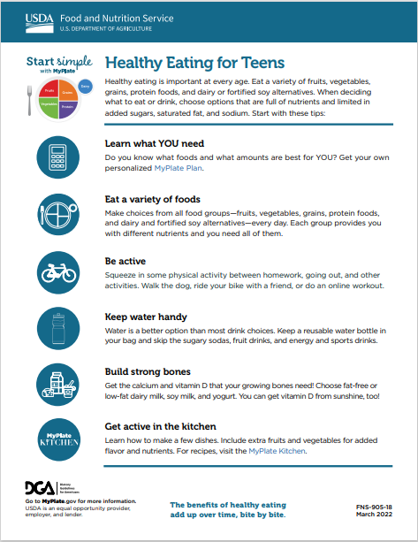

Page 5
WMS News Clip
Welcome March!! March is Youth Arts Month and to celebrate we welcome the open house for our art students whose work was selected to be in the Middle School Art Show at the Dahl Arts Center. This open house will be Thursday, March 7th from 5-7pm. Congratulations art students. Saturday, March 9th is the Lifeways’ AMP Visual and Performance Arts Showcase also at the Dahl Fine Arts Center. We have 32 students who submitted artwork for this event and are invited to come view the art from 5:15-6:00pm. The performance portion of this event will run from 6-8p. Congratulations art students!! The deadline for the “Doodle for Google” contest is Wednesday, March 13th. The deadline for the Railroad Ledger Art Project is Wednesday, April 3rd. Please speak with Mrs. Penfield in Room 130 should you have any questions.
Happy Youth Arts Month West Middle School!!
Reminder:
March 7 – Middle School Art Show Reception at the Dahl 5-7pm
March 9 – Lifeways AMP Event 5:15-6pm, Performance 6-8pm

STUDENT OF THE MONTH nominees chosen by the core teachers for the
month of February are:

6th Grade 7th Grade 8th Grade
Calvin Mills Michael Burke Kai Ditalo
Kaitlyn Steinmetz Kyson Jackson Makenzey Enders
Ardyn Swango Makenna James Logan High Bear
Nathan Wishon Mackenzie Kelley Lily Karn

JUST A REMINDER

March 1 Early Release 1:00
March 1 Personal Transfer Applications open online
March 1,2 All-State Band - Huron SD
March 7 Stevens High School at WMS – Registration for 8th graders
March 8 Dodgeball Tournament @ WMS after school
March 9 Festival of Bands – Monument Theatre
March 10 Daylight Savings Time begins (set you clocks ahead 1 hour)
March 11 Track practice begins
March 12 Women in Science Conference 7th grade girls - SDSM&T
March 12 6th grade Musical – 2:15 Cafeteria
March 15 School Dance – 3:15-4:45 Community Center Gym
March 16 Strings in Concert – Monument theatre
March 17 St. Patrick’s Day
March 22 NO SCHOOL – STAFF PD DAY
March 25-April 1 NO SCHOOL SPRING RECESS

