Robbinsdale Roadrunners

Attendance Policy

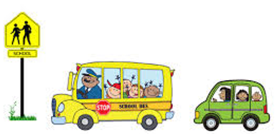

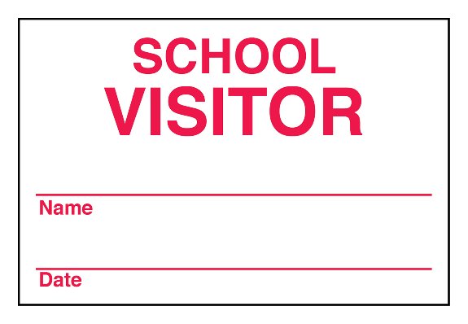

Students should be picked up by 3:10 PM.

ALL visitors to Robbinsdale must obtain a visitor pass at the office.

Students should not be dropped off before 7:40 AM.

Students dropped off AFTER the playground gates are closed must be escorted by the parent/guardian and signed in at the office.

Students may not be checked out after 2:45 PM unless approved by the principal or assistant principal.

Student lineup begins at 7:57 AM & students are in class by 8:00 AM.

School Day

8:00 AM – 3:00 PM