  - April 2019

Informational Items
from the Office
Welcome to Amazing April!
We want to say great work to all of our 3rd, 4th, and 5th Grade students and teachers for their hard work and efforts on the yearly Smarter Balanced Test. Keep showing what you know.

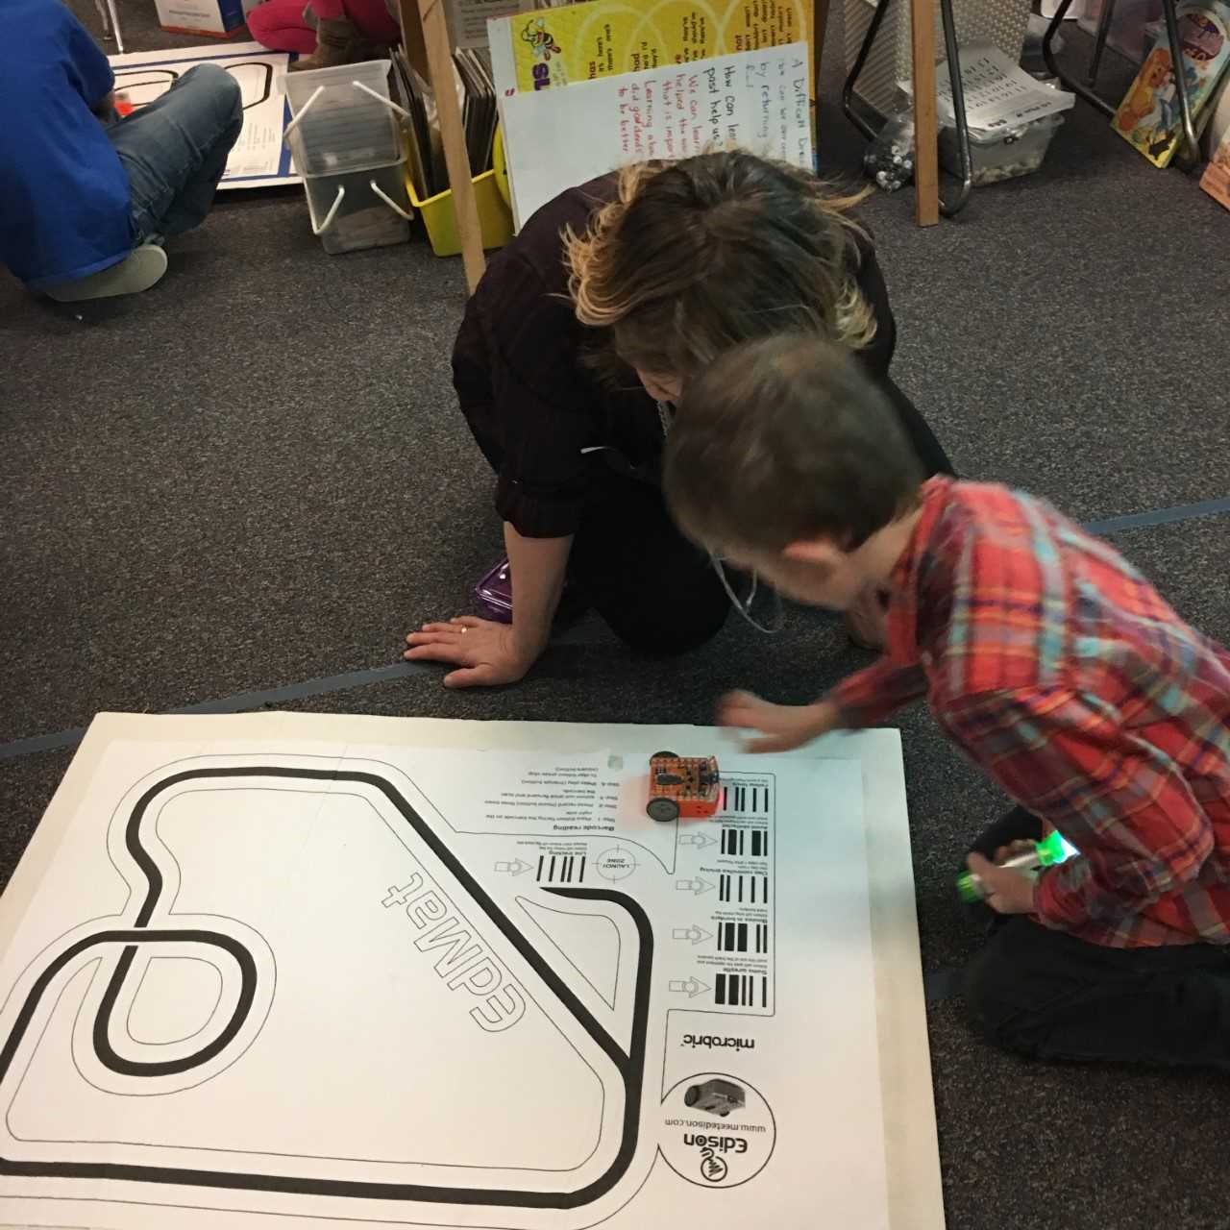

Important Dates
May 3rd-5th Grade Track Meet
May 23rd-5th Grade Celebration-Afternoon
Save the date for April 26th for our PTA Family Science night. We are planning some fun and creative projects and tasks for students and parents.

Congratulations
The following students were recognized for their “Attendance Counts” posters by the United Way: Brently Johnson, Jackson Langdeau, Cashus Burritt, Georgia Palecek, Ella Lewis, Sage Beutler, way to represent RVE!

Evening of Excellence
We are proud to announce that we have five former Rapid Valley students who will be honored as seniors at this year’s Evening of Excellence. We also want to congratulate Mrs. Nugent, Mrs. Jungclaus, and Ms. Ketterling who were nominated by former students to attend as well.

Snow Days
Fingers crossed our worst weather is behind us! We have not received word from RCAS district offices as to how we will make up the four snow days so far this year. Please watch your Tuesday Folder, our website, and FB, or school messenger via email for updated information on this.

RCAS Facilities Task Force
Please take time to attend one of the following dates to hear about the proposals for future facility/building needs. Meetings are from 6-7:30 PM and will be at East Middle School/April 9, West Middle School/April 11, South Middle School/April 23, Southwest Middle School/April 25 and North Middle School/April 26

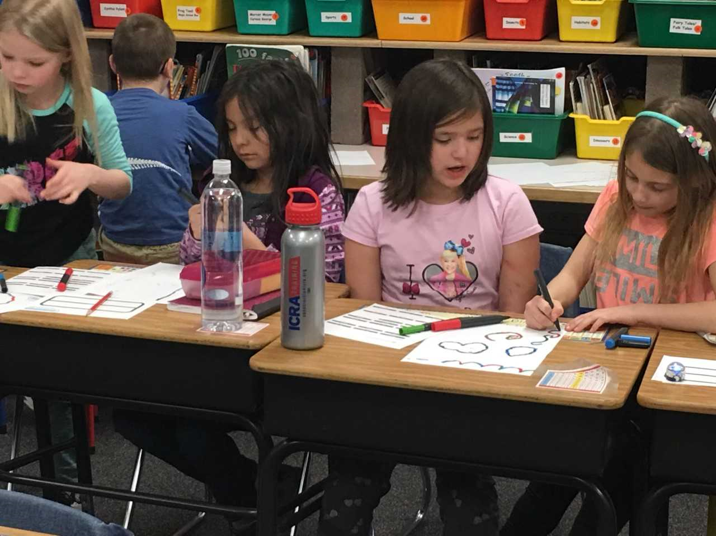
Rapid Valley elementary
2601 Covington Street
Rapid City, SD 57703

